**FLAPPY BIRD GAME**

**(Desktop Application)**

**Prof.Sheetal Atul Phatangare**

Department of Engineering and Humanities(DESH),

Vishwakarma Institute of Technology,Pune-411037,Maharashtra,India

**Author :**

1.Sneha Kalaskar

2.Janhavi Kale

3.Sanjali Kale

5.Hritik Kamble

Department of Engineering and Humanities(DESH),

Vishwakarma Institute of Technology,Pune-411037,Maharashtra,India

**ABSTRACT**

***Flappy Bird was a side scrolling game developed by Dong Nguyen.  
Even though the sport relies on 2D Graphics, it became quite popular on both Android and iOS platforms. The aim of the sport is easy, attempt to fly the bird, which is named “Faby”, between the green pipes without hitting them.  
Due to its addictive nature, the developer of the game discontinued the game from both the channels (Google Play Store and App Store) but a revised version for Amazon Fire TV is launched on Amazon App Store .The popularity of the lead to several replica games and cloned versions were released. In this project, we will take the concept of the sport and implement a Flappy Bird Game using Python language .***

**INTRODUCTION**

Our software project is Flappy Bird. It’s a game application. the sport was designed and built by Dong Nguyen, a developer who lives in Vietnam. Flappy bird may be a side-scroller game where the player controls a bird, attempting to fly between columns of green pipes. The bird are going to be flying until it collisions with a pipe or it fall on ground. It’s an easy game of infinite level type. It’s a challenging game for all .

**Software Project Description :**

We choose game for our first software project. Actually game is entertaining for anybody and in leisure we will spend our time nicely by playing game. The flappy bird game implemented for under desktop.

**Literature Review :**

|  |  |  |  |  |
| --- | --- | --- | --- | --- |
| **Sr. no** | **Title** | **Authors** | **Date of publication** | **Features** |
| **1.** | **A Minimal Training Strategy to Play Flappy Bird Indefinitely with NEAT** | * Matheus Cordeiro Tele informatics Engineering Dept. (DETI) Federal University of Ceara (UFC) Fortaleza, Brazil * Paulo Serafim Instituto Atlantico Fortaleza, Brazil paulo * Yuri Nogueira, Creto Vidal, Joaquim Neto Department of Computing (DC) Federal University of Ceara (UFC) ´ Fortaleza, Brazil | 3 December 2019 | 1. The game Flappy Bird   shows itself as a promising virtual testing environment to optimize agents whose goal is to learn the behavior of nondeterministic phenomena.  2. It is a popular game that was initially developed for mobile  devices. Its goal is simply to keep the bird, the player, alive  as long as possible by passing through a gap between pair of pipes without colliding with them.  3. When the screen is touched, the bird will perform a jump, on all other  moments, it will fall gradually as a result of gravity.  4. The Neuroevolution technique is presented as a powerful strategy to evolve Artificial Neural Networks (ANN) in unsupervised learning problems (problems where there is no input and output table).  5. It offers an alternative way to find the best configuration for an ANN without depending on a correct output value, which is commonly used to generate an error to optimize the networks settings through Descending Gradient algorithms like Backpropagation. |
| **2.** | **Reinforcement Learning in Python with Flappy Bird** | Anthony Le | 1. ay, 2021 | 1. In 2014 the sleeper hit Flappy Bird took the mobile gaming world by storm. It has since been implemented in PyGame but most interestingly it lends itself well to reinforcement learning. 2. The agent (bird) can only perform 2 actions (flap or do nothing) and is only interested in 1 environmental variable (the upcoming pipes). The simplicity of this problem makes it perfect for implementing reinforcement learning in Python from scratch. 3. The reward function was defined to penalise -1000 for a death and 0 otherwise, such that the agent’s focus is the get as high a score as possible. This ensures that the reward function has sufficient impact after each episode, vs an implementation where rewarding +1 for a score increase means that penalisation has little to no effect. |

**Requirements:**A requirement could be a singular documented physical or functional need that a specific design, product or process aims to safety. It will be divided into functional requirements and non functional requirements.  
**Functional :**

2D animation, objectives selection, moving wall, collision detection, moving background etc.  
Non-functional : we will keep the bird playing by pressing space button and move it within the space of pipes.  
**2D Animation** :  
Animation may be a complex subject in game programming. Animation is rapid display of sequence of images which creates an illusion of movement. Java games are expected to run on multiple operating systems with different hardware specifications. Threads give the foremost accurate timing solutions.

**Objective Selection:** We create a bird object which is flying until any collision occurred and therefore the bird is flying within the wall objectives which are begin from top and bottom of the screen.

**Moving Wall :**

The wall moving on and it will come randomly in size and distances. The bird is flying within the middle of the wall.

**Collision Detection :**

When the bird touch the anywhere of a wall it cause a collision. Collision detection is one in all of important task of the game. If the bird touch any wall (pipes) the game will end.

**Moving Background :**

The image used as background image is moving on analogously. We used two same image which are coming one after another regularly.

**Score Counting :**

Score counting is that the interesting for user. By the score the player knows his/her performance. If the bird cross a pipe without collision or not fall in ground his/her score increment one.

**Requirements Traceability Matrix :**

A Traceability Matrix is a document that co-relates any two-baseline documents that need a many-to-many relationship to test the completeness of the link.

Req1 = 2D Animation

Req2 = Objectives Selection

Req3 = Moving wall

Req4 = Collision Detection

Req5 = Moving Background

Req6 = Score Counting

**Tools:**

**Language**: Python

**Data base** : Used File Handling to store the score of the player

**IDE**: An IDE (Integrated Development Environment) contains a code editor, a compiler or interpreter, and a debugger, accessed through a one graphical user interchange (GUI).

**Future Direction:**

We will add more feature to the game and will change the bird and background scenery according to user choice. The status and also the history will going to be saved and that we show a graph where user can see his total performance whether it increasing or decreasing.

**Result and Discussion:**

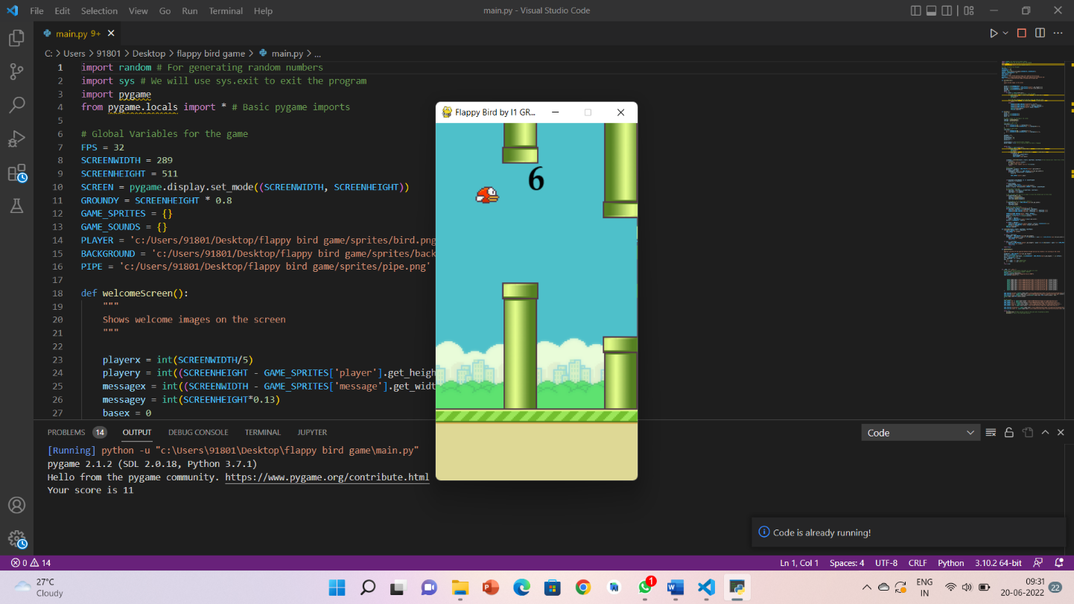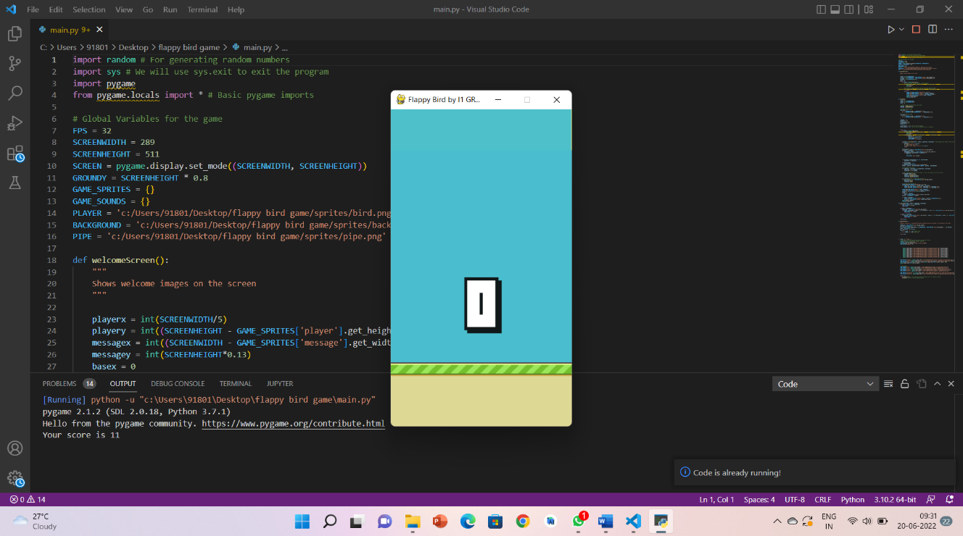

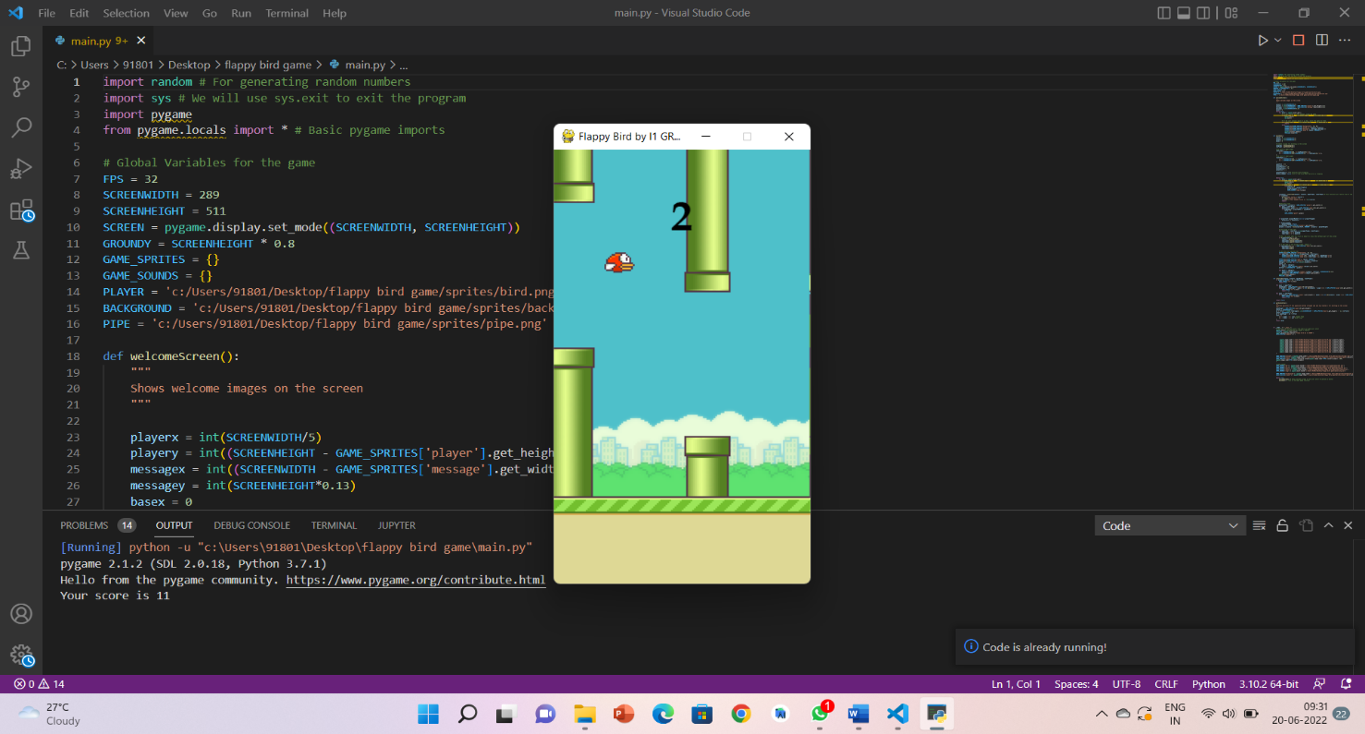

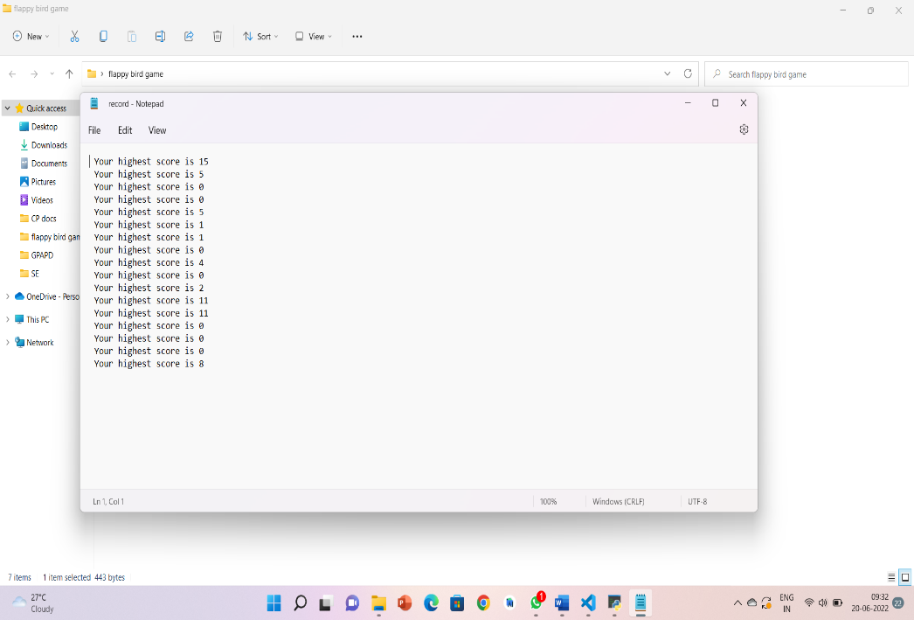

**Conclusion :**

We choice the project to gain proper knowledge to make desktop application. It increased our knowledge for Object Oriented Language (JAVA).Getting experience java GUI. The another important issue is, it’s a game application and it will be recreation for all.

**Acknowledgment :**

We, the group as a whole would like to take this moment and thank Hon. Director and hardworking Head of Department Prof. (Dr.)Sachin Sawant Sir for providing us this opportunity to work on such a skill-developing project. Moreover, despite the best efforts, this work would have straight up not been possible without the invaluable guidance and suggestions provided by Mrs. Sheetal Phatangare Maa`m .

**Refernces :**

1. https://www.wikipedia.org/flappybirds[Accessed at Jan 17, 2019]

2. https://mashable.com/2014/02/10/flappy-bird-story/[Accessed at Jan 24, 2019]

3. https://www.wired.com/2014/02/flappy-bird/[Accesed at Feb 09, 2019]

4. http://frivetenskapligpublicering.blogspot.se/[Accessed at Feb 23, 2019]

5.file:///C:/Users/janha/Downloads/2019_SBGames_AMinimalTrainingStrategyToPlayFlappyBirdIndefinitelyWithNeat_Preprint.pdf

6. https://towardsdatascience.com/reinforcement-learning-in-python-with-flappy-bird-37eb01a4e786